www.5fostering.co.uk Last Review; Dec 2021
getting on with one other : growing up strong
5Fostering Office, The School House, Mill Bank Farm,
Top Road, Hooe, Battle, East Sussex TN33 9HA
Reg Office: Miramar, De La Warr Parade, Bexhill-on-Sea, East Sussex. TN40 1NR

01424 211 122 ~ office@5fostering.co.uk
Reg Company No; 08247567
My5

5Fostering

KS3&4 Young Person’s Guide

What’s inside?

1. Starting point: 3
2. What’s this booklet for . 3
3. What we think: 3
3.1. We think looking after you is about . . . 4
4. Our Fostering Agency 5
4.1. People in our team. 5
4.2. What we all do 5
4.2.1. Personnel Diagram 6
4.2.2. Things for children 7
4.2.3. Things for carers. 7
4.3. Compliments and Complaints 7
4.4. Standards of care and National minimum standards 9
4.5. What to do if you feel worried about something 10
4.6. Safeguarding 11
4.7. Fire safety 11
4.8. Care plans 11
4.9. Being fair – equal chances 11
4.10. Thanks for being with us. 12

Starting point:
When we talked to those we care for they said they would like this booklet to have less words and more pictures. We have also changed some of the words because they were words that didn’t mean much to younger people. If you can help us by suggesting any other changes, please contact your 5F Social Worker, or emailing feedback@5fostering.co.uk.
You could also ask to join one of the groups that help us, for example the QAC who check we’re doing the right thing.
Thanks.

What’s this booklet for
Hi, this booklet is about:
- what we can do for you,
  - how you can tell us what you think,
    - and things that you may ‘need’.

What we think

We think it’s REALLY important that we do everything with young people and children in mind.
We try hard to . . .
. . . give great training for carers to help them give. . .
. . . the best care possible for you, so that . . .
. . . you grow up in a warm, caring and stable home having
. . . a safe and fun time so . . .
. . . you do REALLY well in everything, and that. . .
. . . you’re respected by everyone
. . . and you can deal with any problems you have (sometimes with our help!).
- This is so you can deal well with any problems you’ve faced in the past, get better at coping with things now, and be unworried about them in the future.

We think looking after you is about . . .
. . . .having the greatest chances to;
Keep safe, but love a bit of challenge;
Stay healthy and happy, but enjoy trying hard to get better at things;
  - to respect yourself, your friends and others;
Enjoy doing and learning new things;
Have dreams of what you want to do and try to get them (with help);
Be helpful and respected - especially by those around you.

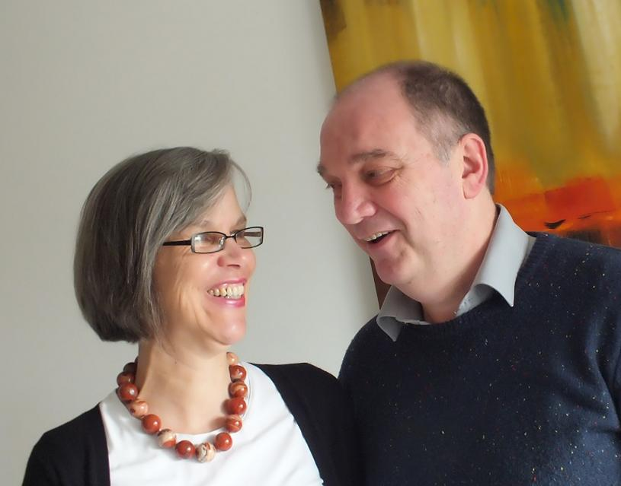
Our Fostering Agency

People in our team.
Rob and Katie are the ones who run the agency, but they are helped by a team of people.
We also have a group of people who keep an eye on us called the ‘Quality Assurance Committee’ (or ‘QAC’ for short). We’d love it if you wanted to join in the QAC some day – just let us know and we will try to arrange it.
Derek’s team look after carers and their families. We also have social workers who assess people who want to be 5F carers.
Sarah’s team help people to know about 5Fostering, they look after the office and help the staff and carers keep records.

Your Voice
We have someone who has a special job of finding out what you want called Kim. Her job is to listen to your opinion and make sure you are heard. She is one of the people you can call or contact if you are scared, worried or unhappy about something. She will always listen when she visits your placement, or you can ask to talk to her.
We also ask our young people what questions we could ask when we are approving foster carers and reviewing their care each year.

What we all do
We give children and young people all kinds of families to be a part of. This can be for a few nights or until they are eighteen, and sometimes when they are older. The children and young people we care for could be disabled or able bodied, they could be on their own or with their brothers and sisters, they could be given a home in an emergency or take their time moving in.
Have a look at the diagram below. Who’s at the top? The reason there is an arrow going up AND down in the diagram is because we are all here to help YOU, the young person we care for. You can help us to do well by telling me or your social worker how we are doing and how we can do things better.

People Picture
Children and Young People we Care For
(You)

Your Fostering Family’s Social Worker
Your Social Worker (But they work for your Local Authority not 5Fostering)
Independent Reviewing Officer (IRO)
(They check everyone is doing their job supporting your placement)
Rob, Katie and the 5Fostering Team
John and the QAC
(Quality Assurance Committee)
Your Carers, their Family and Friends.

Things for children
We can do loads of things to help you if it’s OK with your Social Worker.
We choose your carers carefully to match your interests.
We can help you with
school stuff,
seeing your family,
having a go at new things,
helping you stay fit and healthy,
build your mementoes and build a story of your life,
arrange for a ‘buddy’ (befriender) to talk to and take you out if you want.
You can even get involved in running 5Fostering as a part of the QAC and, most importantly ~ have fun!
We usually start your time with us with a trip or visit – like going to ride on real mini steam engines at Romney, see wild animals at Port Lympne Safari Park, or ‘real’ dinosaurs at the Natural History Museum, go to watch Brighton play at the Amex Stadium, or one young person went to see a band at the O2 with their new family.

Things for carers.
We do lots of helpful things for your carers helping them to give you good care, but one thing we hope for is that we can also have some fun.
We do things like making sure the carers will be the right ones for you, we help them get new skills, and they can share their skills with us. All of it is to make sure your carers and you have the best chance to get on with each other.

Compliments and Complaints
We are keen on knowing what you think of what we do for you. For example; Is 5Fostering doing its job properly? What are we doing well? How could we do better? What can we do to help you with any worries?
If you have anything good to say, or something we do that makes you cross, or have a worry about ANYTHING – make sure you tell someone. Then we can do something about it.
There is NO WAY that you will be in trouble – in fact we will thank you for being honest. Someone may be able to talk on your behalf (they are called an ‘advocate’) and will keep you in mind and try to make things better for you.
If you are worried, you could tell . . .
  - your carer,
  - your support worker (if you have one)
  - anyone in 5Fostering
  - your social worker
  - your teacher or classroom helper
  - lunchtime supervisor or play leader
  - in fact, anyone you feel you can trust (see the cartoon below)
They may not be able to keep it a secret because it might be too important, but please, please tell someone – you will be doing the RIGHT THING.
You could also let us know by calling or texting 01424 211 122 or 07592 202 873, or email feedback@5fostering.co.uk or office@5fostering.co.uk, or just tell someone when you meet them.
We will deal with it and tell you what we have done.
If you are still not happy with what we have done you can contact our Quality Assurance Committee (QAC) (you could write a note or letter to them – we won’t read it) and they will ask us what has been done.
You can also talk to someone outside of our agency. Someone like
your Social Worker, or
your Independent Reviewing Officer (IRO)
(your carer or Social Worker will have their number),
The Children’s Commissioner, - free call ‘Help at Hand’ on 0800 528 0731
Email: help.team@childrenscommissioner.gov.uk
Sanctuary Buildings, 20 Great South Street, London, SW1P 3BP
Child Line (0800 11 11)
NSPCC (0808 800 5000)
Barnardo’s (0808 800 5000)
or Ofsted on 0300 123 1231 or enquiries@ofsted.gov.uk
Ofsted
Piccadilly Gate
Store Street
Manchester
M1 2WD
We would have hoped to have sorted it out long before then!
A few other numbers you might find useful are national children and young people’s support agencies

Standards of care and National minimum standards
There are 31 National Minimum Standards and we aim to do better than all of them.
We can give you a copy if you wish.

What to do if you feel worried about something
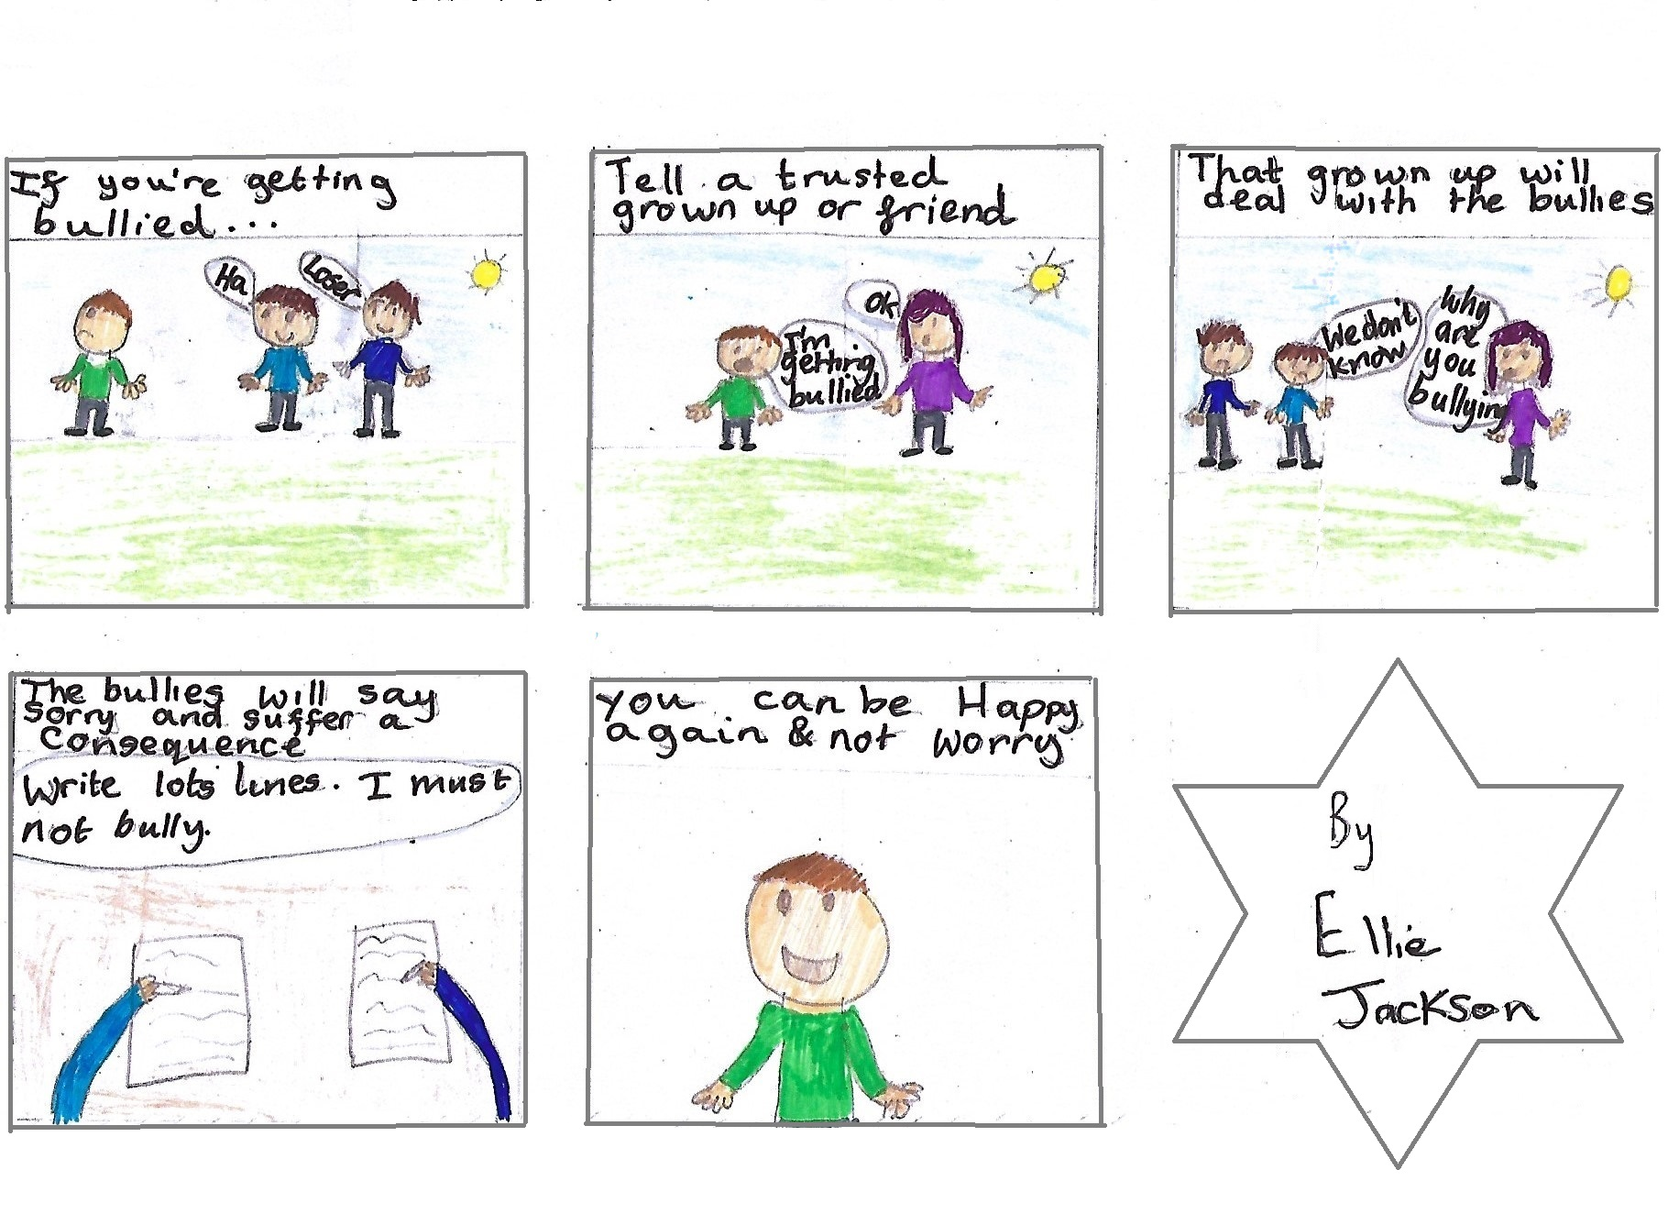
– tell someone you trust!

Cartoon drawn by a young person in our care: EJ (11yrs)

Safeguarding
Safeguarding is about making sure you are SAFE - YOU have a big part to play in this.
We will be doing lots of things to help those around you keep you safe, but you’ve got the biggest part to do as you will always be there!!! We hope to help you in keeping yourself safe but enjoy a bit of challenge that won’t do you damage.
If anything happens to you that you are not happy with, we hope you will talk to anyone in 5Fostering who can pass on your worry. It will ALWAYS be the right thing to talk to one of us about it.

Fire safety
Fire is incredibly dangerous and can sneak up on you. Along with the other things to keep you safe, we make sure your carers know how to keep you safe from fires. We also make sure your home is safe from anything that can set alight to things.

Care plans
The plan for your stay in fostering is made up of
- what you want to happen, and
- the decisions the judge wants to happen to make you safe and thrive,
- but also what your social worker’s team and 5Fostering can provide.
It’s important that you know what the plan is and so it will be shared with you. Ask if you are not sure.
We’ll check to see if you’re OK every few weeks, but your social worker will be coming to see you as well. You, or your carers, can always ask to meet in the meantime.

Being fair – equal chances
Figure 1; From http://legal-aware.org/
We believe everyone should have the same opportunities in life despite any differences or disabilities. Although some people may need more care and attention, it is only fair that everyone is given a fair chance.

Thanks for being with us.
We really hope that you enjoy your stay with us and that you feel confident enough to allow us to help you to strive for great things.
We hope you will use our extended family and ‘positive partnerships’ to develop a resilience so that you can deal with any bad stuff of your past, become proud members of your family and community, and be a great mum or dad of your own family in the future.

All the very best and kindest of regards,

Rob & Katie Edworthy
. . . and all of the team behind us!

